Solution: Typelists

In this lab, you will use the Typelist Editor and the Entity Editor in Guidewire Studio to modify the TrainingApp data model. You will first edit an existing typelist. Next, you will create two new typelists. Finally, you will edit existing entities and associate the new typelists with each respective entity.

Requirements

This lab requires that you use TrainingApp 8.0 and Guidewire Studio 8.0.

Overview

The fictitious Acme Insurance Company is your customer. Your job is to make the necessary changes to meet customer requirements. Acme wants to broaden the various contact tiers for contacts. In addition, Acme wants to capture details about contact interactions including the type of communication channel and the reason for the interaction.

1. Extend a typelist with new typecodes

In this exercise, you will extend the ContactTier typelist using the Typelist Editor in Guidewire Studio.

Tasks

1. Open Guidewire Studio
2. Edit the ContactTier typelist
3. Navigate to the ContactTier typelist.
4. In the Typelist Editor, add a Bronze typecode that displays between Unknown and Silver.  
   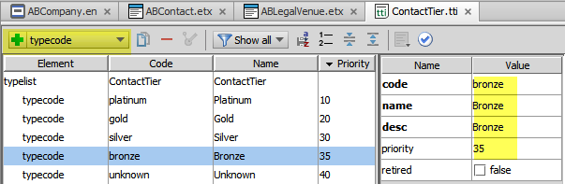
5. Validate your changes in the Typelist Editor.
6. Create new typelists

In this exercise, you will create and define two typelists in Guidewire Studio using the Typelist Editor. The InteractionReason_Ext typelist will describe the reasons for contact interactions. The ChannelType_Ext typelist will describe the various channels of communications for interactions.

Tasks

1. Create the InteractionReason_Ext typelist
2. In the Project View, select the ...\ config\extensions\typelist folder.
3. In the context menu, select a new Typelist.  
   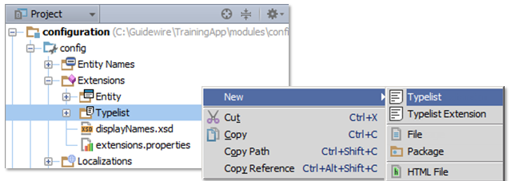
4. In the Typelist dialog, enter InteractionReason_Ext. Click OK.  
   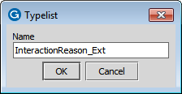
5. In the Typelist editor, add the following typecodes to display in the order listed using recommended naming conventions:

|  |
| --- |
| Typecode |
| Request |
| Complaint |
| Courtesy Contact |
| Other |

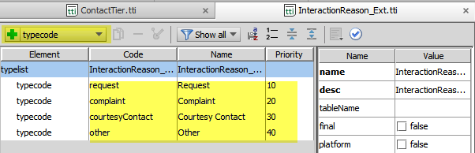

1. Validate your changes in the Typelist Editor.
2. Create the ChannelType_Ext typelist
3. Select the ...\ config\extensions\typelist folder and create a new Typelist named ChannelType_Ext.
4. In the Typelist editor, add the following typecodes to display in the order listed using recommended naming conventions:

|  |
| --- |
| Typecode |
| Email |
| Phone |
| Postal Mail |
| Fax |
| In Person |
| Other |

 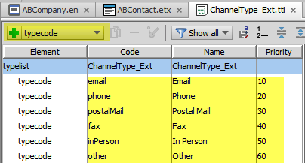

1. Validate your changes in the Typelist Editor.
2. Add typekey fields to related entities

In this exercise, you will edit the related entities and add new typekey elements for the newly created typelists. For each new entity element, remember to set the nullok attribute to true if not specifically defined to be false.

Tasks

1. Edit the Interaction_Ext entity
2. Add a typekey field for the InteractionReason_Ext typelist where nullok is false using the recommended naming convention.  
   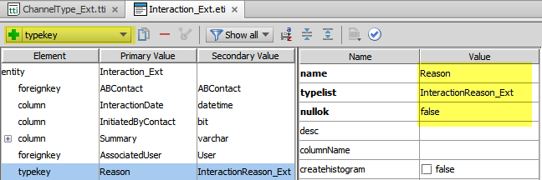
3. Add a typekey field for the ChannelType_Ext typelist using the recommended naming convention.  
   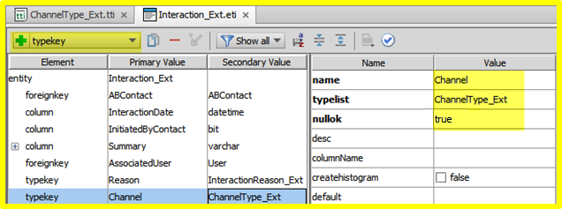

Write it down

What is the significance of setting nullok=false for the typekey field that references InteractionReason_Ext?

|  |
| --- |
| This means that every interaction must have an interaction reason (and the reason will always be one of the typecodes in the typelist). |

Optional verification

1. Build the data dictionary and verify your changes
2. From the bin folder, open a command window and enter the command to build the data dictionary.
3. In Windows Explorer, navigate to the data dictionary and open the data dictionary using Internet Explorer.
4. Verify the new typelist references in ABContact and Interaction_Ext.

Deployment

1. Deploy your changes
2. From studio, restart the server using Debug 'Server'.
3. If open, review the Messages Make window for compilation errors.
4. Review the Debug console for errors.
5. Verify that the application is running in the Debug console.

|  |  |
| --- | --- |
|  | Stop and ask your instructor to review your completed lab. |